PRESENTATION TEMPLATE FOR YOUTUBERS!
Hi, My name is ______________ and I am going to show you my YouTube channel. The name of my channel is _____________________. I selected this name because _____________________________________________________________________________________________________________________________________.
I currently have ___________ subscribers and ____________ videos. I created this channel to _________________________________________________________________________. I would like to ____________________________.
In the future my channel ___________________________________.
One of my favorite videos is ____________. I used the program or website called ___________ to create and edit my videos. I get inspiration from other channels like ______________________ and _____________________. These are similar channels like mine.
I would like to show you one of my videos from my channel.
(SHOW US A VIDEO 5 Minutes or less)
This video ___________________________________________.
My favorite Youtuber is ______________________. I would like to show you one video from one of my favorite YouTubers.
(TITLE OF VIDEO)____________________________________
(SHOW US A 5 minute or less video from your favorite YouTuber)
I like this YouTuber because __________________________________________________________________.
I hope to grow my channel like my favorite YouTuber has done with his or her channel..
Thank you.
PRESENTATION TEMPLATE FOR NITRO TYPE!
Hi, My name is _____________ and I would like to show you my progress and stats on a typing website called NITRO Type. I can type ___________ WPM and I usually have an accuracy of about ________________ %. I am generally on average a __________ (slow, medium, fast) Typist.

I _________________ (can or cannot) beat Ms. Todoric. Sometimes I beat Ms. Todoric. She types at a speed of ________.
I like driving the _____________________.
I have ____________ cars in my garage.
I have $ _______________ in my account. I like to ________________________ (do what) with my nitro type cash.
I have earned ____________________ Challenges on nitro type. (no, one 2 etc.. challenges). I am most proud of ____________________________________________________________.
My screen name is _____________________. I selected this screen name because ____________________________________________. I think Nitro Type is ________________. I would like to ___________________________.
Some Nitro Type channels I follow and like include _______________________________________________________________.
(Show Class a Nitro Type Channel and Video)
Title of video __________________________________________
I plan to become a better typist and increase my typing skills with this website.
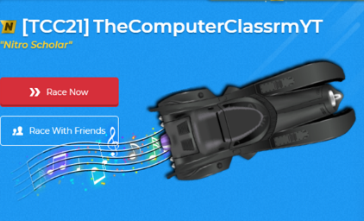
Thank you.

PRESENTATION TEMPLATE IN GENERAL!
Hi, My name is ________________ and I would like to discuss all the things I’ve learned in Technology class this past year.
I learned… ______________________________________________________________________________________________________________________________________________________________________________________________________________________________________________________________________________________________________________________________________________________________________________________________________________________________________________________________________________________________________________________________________________________________________________________________________________________________________________________________________________________________________________________________________________________________________________________________________________________________________________________________________________________________________________________________________________________________________________________________________________________________________________________________________________________________________________________________________________________________________________________________________________________________________________________________________________________________________________________________________________________________________________________________________________________________________________________________________________________________________________________________________________________________________________________________________________________________________________________________________________________________________________________________________________________________________________________________________________________________________________________________________________________________________________________________________________________________________________________________________________________________________________________________________________________________________________________________________________________________________________________________________________________________________________________________________________________________________________________________________________________________________________________________________________________________________________________________________________________________________________________________________________________________________________________________________________________________________________________

THANK YOU.

