DEGREE INTERNET RESEARCH ASSIGNMENT
Directions: Find the home page for Degree deodorant and answer these questions.

- What is the website address for the Degree deodorants and antiperspirants?
- www.deoderant.online
- www.degree.com
- www.degreedeodorant.com
- www.dc.com

- Circle True or False. Degree is on Instagram, Facebook, YouTube and Twitter.

- Circle True or False. Sweat is natural and happens to all of us. It’s a mix of salt, water, proteins and oils that’s produced by over 3 million sweat glands all over your body.

- Why do we sweat?
  - We sweat to cool down.
  - We sweat to smell good.
  - People don’t sweat.
  - None of the Above.

- Fill in the blanks.
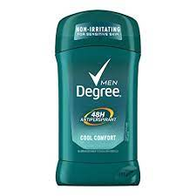
When we get sweaty, it’s from either two types of sweat glands on the skin: ________ – found mainly in the underarm area – and ________ glands, which are found all over the skin surface.

- “BO” stands for…
  - Body Odor
  - Big Octopus
  - Beauty Over
  - Bold & Beautiful

- True or False. Sweating is healthy and normal.

- True or False. Unilever tests their products on animals.

- What is the phone number to contact Degree if you would like to speak to them?
  - 1800-Degree
  - 1888-234-6543
  - 1-866-334-7331.
  - 1-866-334-7333

- Circle True or False. You can show Degree your moves on social media by these tags…
  - @Degree
  - #KeepMoving
  - #DegreePartner

